Chemistry Calculator

# Description

* 1. Chemistry Calculator is a program that performs basic and higher level standard calculator functions. It also eases the calculation of Atomic Weight and Molar Mass equations by allowing the user to click on an element from the Periodic Table and insert the value of the select element directly into the calculator. The user also has the ability to input a chemical formula directly into the Atomic Weight and Molar Mass applets.

# Requirements

* 1. This software package is ‘stand-alone’ and does not need to be installed to operate.
  2. This software does not require administrative privileges.
  3. The latest Java runtime for your system is recommended.
  4. A mouse, pen, touchscreen or other pointing device is recommended.

# Installation

* 1. Download the Chemistry Calculator from <https://github.com/icc1/SE1project.git> . Chemistry calculator can be run directly from the downloaded file and does not require installation.

# Operation

## Calculator Functions

* + 1. The Chemistry Calculator opens to the calculator on startup.
    2. 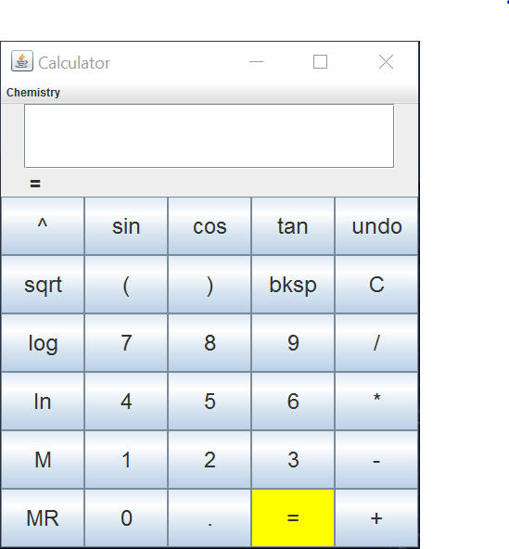 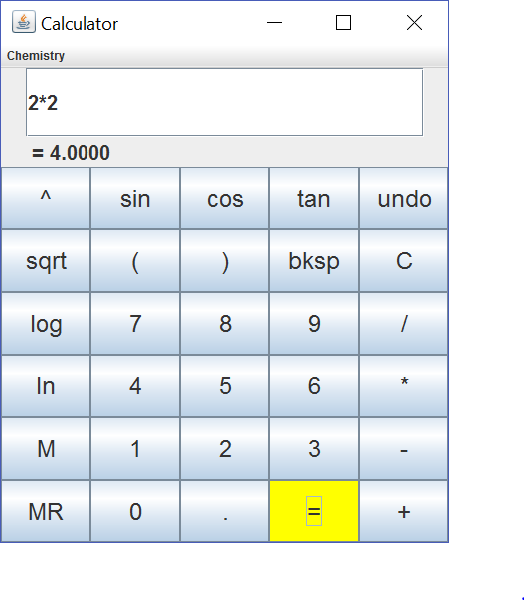
       1. Figure 1 Main Calculator
    3. You may type or use a pointing device to use all calculator functions.
    4. Your input will be displayed the main window and your answer will be displayed underneath after pressing the ‘=” button.
    5. To use your keypad select the area inside the main window to display the cursor to begin input. You must press the ‘=’ button to see the results of your calculation.
    6. Press ‘C’ to clear the display and ‘bksp’ to undo typing.
    7. Press ‘^’ to assign a power.
    8. All other calculator functions are standard.
    9. Close the program by clicking the close button ‘X’ in the upper right corner.

## Periodic Table

* + 1. 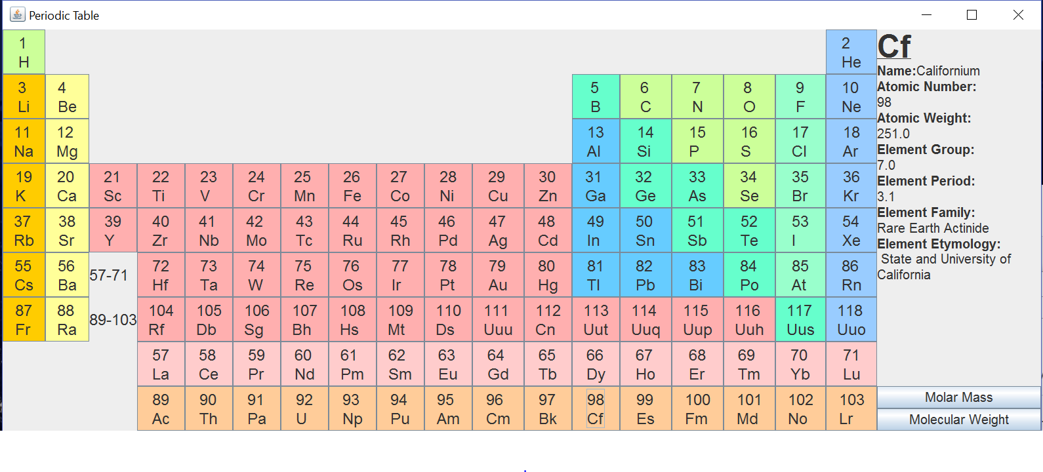
       1. Figure 2 - Periodic Table
    2. Selecting an element will display details of the element in the information pane to the right of the table. The information includes:
       - 1. Symbol
         2. Name
         3. Atomic Number
         4. Atomic Weight
         5. Element Group
         6. Element Period
         7. Element Family
         8. Element Etymology
    3. You may select Molar Mass from the bottom right side of the table to open the dialog to send the calculation to the main display of the calculator.
    4. You may select Molecular Weight from the bottom right side of the table to open the dialog to send the calculation to the main display of the calculator.

## Molar Mass

* + 1. 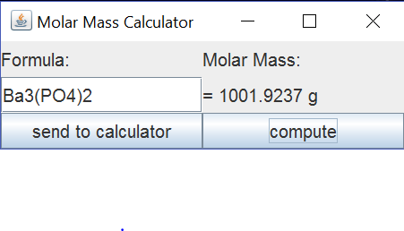
       - 1. Figure 3 - Molar Mass
    2. Molar mass will allow you to take the Atomic Weight and insert it into the calculator main window.
    3. You may type (Case Sensitive) a molecular equation and have it calculate the mass. The total may also be sent to the main Calculator window for further use.
       - 1. Ba3(PO4)2 Should be input as Ba3(PO4)2.
    4. Compute will solve your equation.
    5. Send to Calculator will send the data in the window to the main window of the Calculator.

## Molecular Weight

* + 1. 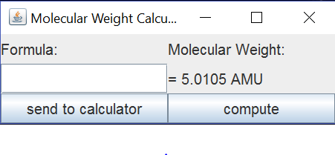
       - 1. Figure 4 - Molecular Weight
    2. Molecular Weight will allow you to take the Molecular Weight and insert it into the calculator main window.
    3. You may type (Case Sensitive) a molecular equation and have it calculate the combined weight. The total may also be sent to the main Calculator window for further use.
       - 1. Ba3(PO4)2 Should be input as Ba3(PO4)2.
    4. Compute will solve your equation.
    5. Send to Calculator will send the data in the window to the main window of the Calculator.

# Support

## Warranty & Support

* + 1. This is software is released as is and has no current technical support available. As more functionality is added, support options may be released in future updates.

## Authors:

* + 1. CEN 3031 Group 11
       - 1. Ian Connolly
         2. Christopher Hanes
         3. Dwight Sims